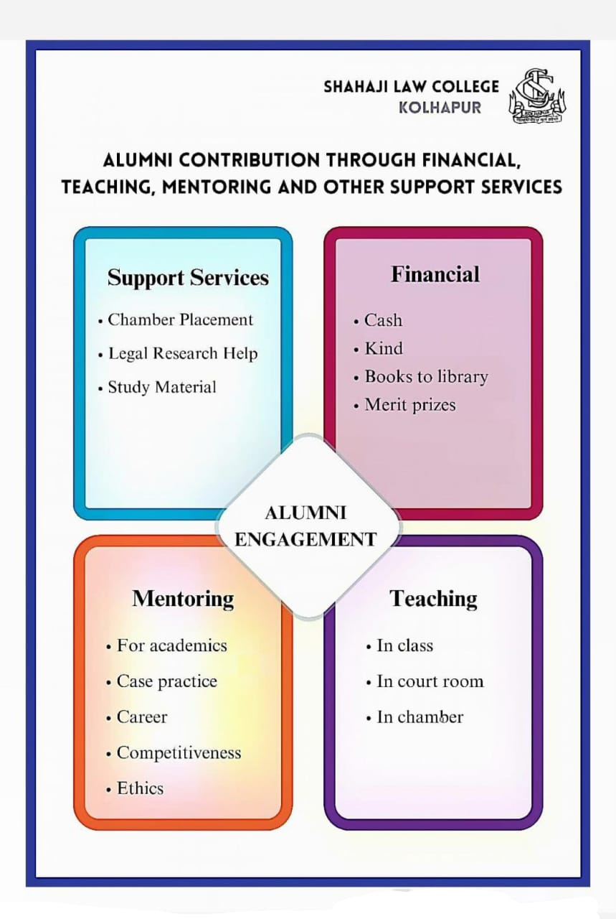

**Contribution of Alumni for Student Support & Progression**

**Our Alumni supports the Institution in following ways -**

* Conducted Guest lectures on various legal Topics
* Assisted students during Moot Court Competitions
* Arranged and also guided students during Court and Chamber Visits
* Assisted students for the placement and Internship
* Provided feedback on curriculum enrichment
* Raised funds and financially supported the institution
* Assisted the institution to arrange various Events and programs.

**FINANCIAL CONTRIBUTION**

|  |  |  |  |
| --- | --- | --- | --- |
| **Sr. No** | **Academic Year** | **Amount** | |
| 1. | 2018-19 | 19,403 | |
| 2. | 2019-20 | 23,396 | |
| 3. | 2020-21 | 27,200 | |
| 4. | 2021-22 | 3,57,833 | |
| 5. | 2022-23 | 6,51,237 | |
| 6. | 2023-24 | 60,000 | |
| **Total** | | | **11,39,069/-** |